5.96: (a) 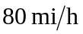 is 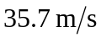 in SI units. The centripetal force needed to keep the car on the road is provided by friction; thus
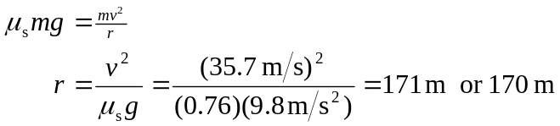
(b) If 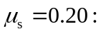
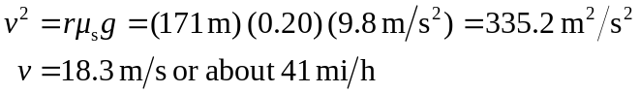
(c) If 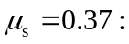
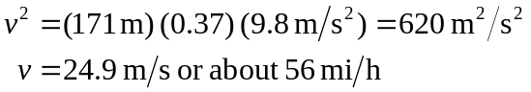
The speed limit is evidently designed for these conditions.

